**PF ASSIGNMENT#6**

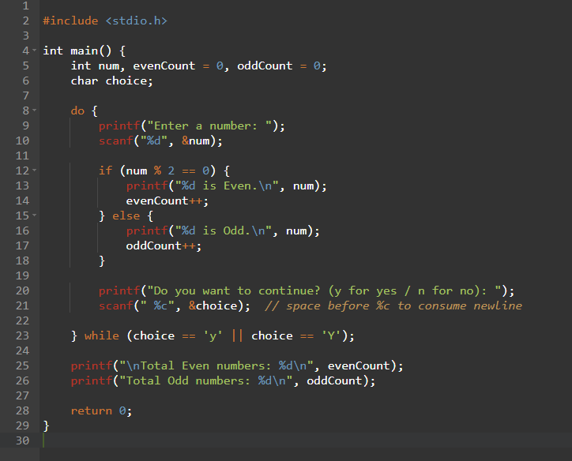*TASK 1:*

*TASK 2:*

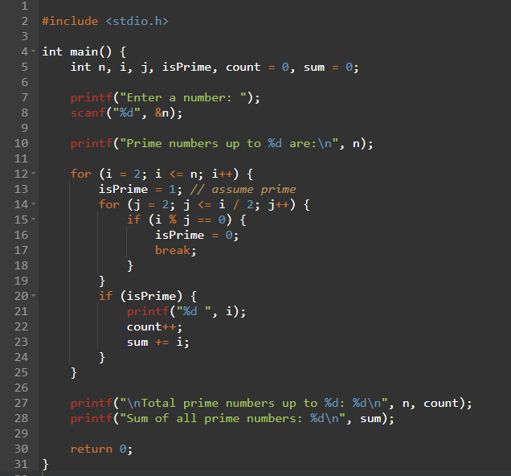

*TASK 3:*

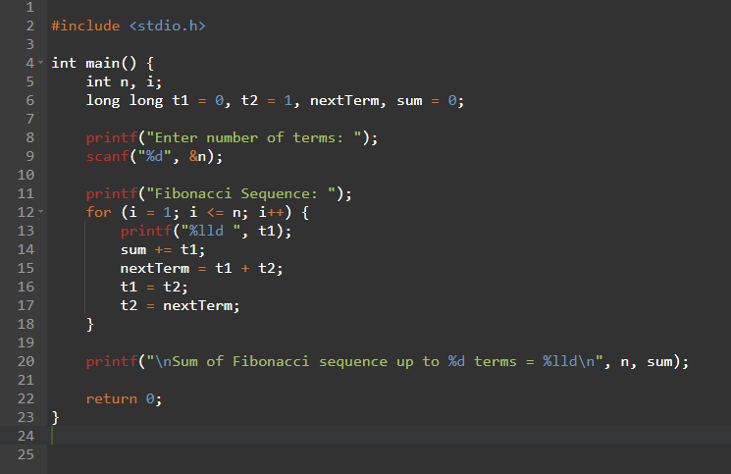

*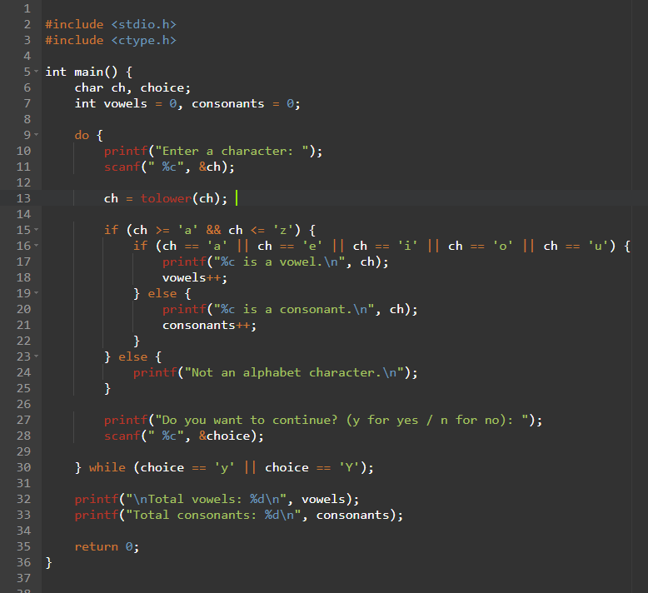TASK 4:*

